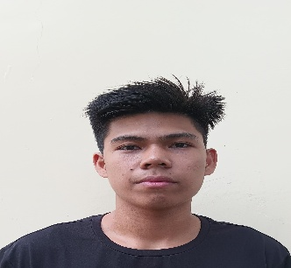

NEL CABAÑOG GONZALES

[lenselaznog09@gmail.com](mailto:lenselaznog09@gmail.com)

Mobile Number: +639657061678

BIT- Computer Technology Candidate

Permanent Address:

Guiwanon, Ginatilan, Cebu 6028

Birthdate and Birthplace:

November 9, 2002 – Macrohon, Southern Leyte

Religion:

Roman Catholic

Civil Status:

Single

Education:

College

BIT – Computer Technology

Cebu Technological University – Ginatilan Extension

Poblacion, Ginatilan, Cebu

2021 - Present

Secondary

Guiwanon, National, High School

Guiwanon, Ginatilan, Cebu

Class of 2021

Primary

Central Elementary School

San Roque, Ginatilan, Cebu

Class of 2015

Technical Skills:

* Programming
* Networking
* Computer Aided Design
* Industrial Automation

Accomplishments:

* Proficiency in writing efficient and effective code using the C programming language.
* A competent CAD operator.
* Successfully completing networking projects, such as setting up local area networks (LANS), configuring routers, or Implementing secure wireless networks
* Participated networking in showcasing my skills in network troubleshooting and problem-solving

References:

Allan Walker Mel Torres

Music Artist CTU -Ginatilan Extension Student

09738384924 09384737273

Dave Intes

CTU -Ginatilan Extension Student

09727372729